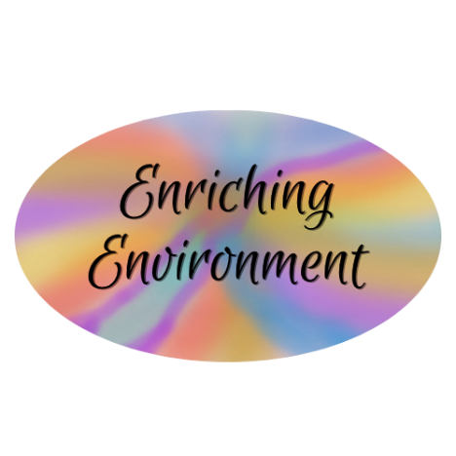

Helping Children Reach
Their Potential

...PRESENTS
FUN FRIDAY

CREATIVE EXPRESSIONS, ORAL PRESENTATIONS,
ARTISTIC ENCOUNTERS, GAMES, AND COLLABORATION

WHEN: September 12th & 19th September
9:00 a.m. to 12:00 p.m.
WHERE: 5638 Regent Hill Terrace West
Palmdale, CA 93551

COST: $40.00/Friday

LEAP Into Learning
While Having FUN !

For more information and to enroll call: (661) 499-6161

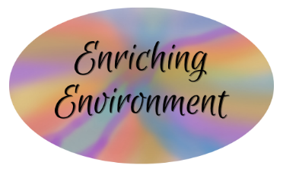
Writing Curriculum Overview

School Grade | Students per  session | Weekly Sessions
3rd - 5th | 4-6 | Tuesday & Thursday (9:00 am – 10:00 am)
6th - 8th | 6 - 8 | Tuesday & Thursday (10:30 am – 11:30 am)

WRITING DOMAINS | EXPECTATIONS
- Point of View/Argumentative (opinion pieces supported by reasons/information)  - Personal Narrative &  Imaginative Narrative  (chronological, thematic, informational)  - Expository  - Writing to inform  - Writing to explain  (to tell how or why)  - Response to Literature (characters, setting, conflict, plot, theme, summary, etc.)  - Research Report | - Students will deepen their understanding of the purpose of and effective writing for each writing domain (type) through a variety of writing elements mini-lessons, teacher modeling, and writing prompts.  - Students will apply the writing process to enhance their writing at least once during each writing domain session:  - Brainstorm/prewrite  - Make a plan  - Sequence for writing  - First draft  - Revise & edit  - Final draft  - Teaching will be differentiated based on students' abilities and grade level standards.  - Students will interact with each other through team writings, orally rehearsing writing, etc.  - Students will practice journal writing.  - Goal: During the school year, students will master grade-level writing standards.

2025-2026 School Year
Writing Curriculum
Schedule and Unit Fee

Month | Tuesday  Dates | Thursday  Dates | Writing Focus | Unit Fee
2  September  Unit 1  Unit 1  0  2  5 | 2, 9, 16, 23 | 4, 11, 18, 25 | Introduction to Writing &  Personal Narrative  Thematic, Informative | 1  $160.00
October  Unit 2 | 7, 14, 21, 28 | 9, 16, 23, 30 | Imaginative Narrative  Chronological | 2  $160.00
November  Unit 3 | 4, 18 | 6, 13, 20 | Expository Writing  Writing to Inform | 3  $100.00
December  Unit 4 | 2, 9, 16 | 4, 11, 18 | Point of View/Argumentative  Writing to Share Opinion, supported with evidence | 4  $120.00
2  January  Unit 5  0  2  6 | 6, 13, 20, 27 | 8, 15, 22, 29 | Expository Writing  Writing to Tell How | 5  $160.00
February  Unit 6 | 3, 10, 17, 24 | 5, 12, 19, 26 | Expository Writing  Writing to Explain Why | 6  $160.00
March  Unit 7 | 3, 10, 17, 24 | 5, 12, 19, 26 | Response to Literature  Characters, Setting, Conflict,  Plot, Theme, Summary, etc | 7  $160.00
April  Unit 8 | 7, 14, 28 | 9, 16, 30 | Research Writing | 8  $120.00
May  Unit 9 | 5, 12, 19 | 7, 14 | Project-Based Writing | 9  $100.00

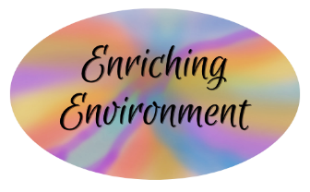
Additional Services

- Tutoring: Specialty in English Language Arts (reading & writing)
- Arranged on an individual basis
- $30.00 for each one-hour session
- Number of sessions based on individual need

- Sewing Lessons: To begin in September 2025
- 1½ -hour private or group sessions
- $35.00/session
- Arranged on an individual or group basis
- Project-based or client-need-based

- Fun Fridays
- Second & Third Fridays of the month, 9:00 a.m. to 12 p.m.
- Activities vary monthly (creative expressions, oral presentations, artistic encounters, collaboration, games, student success & life skills, etc.)
- $40.00/Friday

